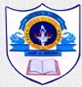
INDIAN SCHOOL AL WADI AL KABIR
DEPARTMENT OF SOCIAL SCIENCE
PRE-MID TERM ASSESSMENT- 2023-24
Answer Key
CLASS: VI Max: Marks: 30
Date: 25/05/2023 Time: 1 Hour
 | SECTION – A (History) 15 Marks
I | Multiple Choice Questions: - | 2 Marks
1 | The word ‘India’ is derived from the word___________ which is called Sindhu in Sanskrit.  a) Bharat b) Indus c) Hindos d) Indos | 1 Mark
2 | The language used by the ordinary people for conversation was ________________  a)Hindi b) English c) Prakrit d) All of these. | 1 Mark
II | Fill in the blanks: - | 2 Marks
3 | The process of digging the earth to find out the old objects are called excavation. | 1 Mark
4 | Tributaries are the smaller rivers which merge into a bigger river. | 1 Mark
III | Match the following: - | 2 Marks
 | Column A Column B  - Narmada Valley a. Cities about 2500 years ago  - Magadha b. Hunting and gathering  c. The First big kingdom  Answers: - 5. b, 6. c | 2 Marks
IV | Answer in one or two sentence:- | 2 Marks
7 | Why do you think ordinary men and women did not generally keep records of what they did?  - Ordinary men and women did not feel the need of recording what they did.  - Also, they lacked proper writing methods. | 1 Mark
8 | Who are ‘Archaeologists’?  Archaeologists are the persons who study the objects of the past. | 1 Mark
V | Answer in brief:- | 4 Marks
9 | List one major difference between manuscripts and inscriptions.  Manuscripts - Manuscripts are the old books that given in handwritten account. - These are written on leaves and barks of trees. Inscriptions - Inscriptions are engraved form of writing used for various purpose. - These were written on hard surface. Eg . Stones, metals etc.. | 2 Marks
10 | Observe the picture and answer the questions below: -  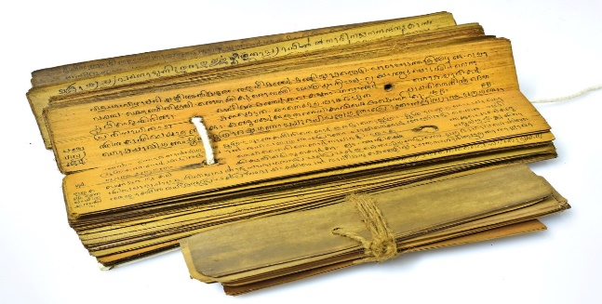  - Identify and name the given picture  Manuscript.  - Which language is used for writing?  Sanskrit Language | 2 Marks
VI | Answer the following: - | 3 Marks
11 | What were the subjects on which books were written in the past? Which of these would you like to read?  Ancient books covered subjects like:  - (i) Religious beliefs and practices (ii) Lives of kings (iii) Medicine (iv) Science (v) Poetry (vi) Drama (vii) Epics  - It would be really interesting to read the epics of the past.  - The Ramayana, The Mahabharata and the Upanishadas are some of the religious epics of the past battles and their victories. | 3 Marks
 | SECTION – B (Geography) 15 Marks
VII | Multiple Choice Questions: - | 2 Marks
1 | The persons who study about the celestial bodies are known as _______.  a. Astronomers b. Geologists c. Explorers d. Scientists | 1 Mark
2 | The biggest planet in the Solar System.  a Saturn b. Jupiter c. Uranus d. Earth | 1 Mark
VIII | Fill in the blanks: - | 2 Marks
3 | A group of Stars forming various patterns is called a constellation. | 1 Mark
4 | Planets do not have their own heat and light. | 1 Mark
IX | Match the following: - | 2 Marks
 | Column A Column B  - New Moon night. a. Universe  - Galaxies b. Poornima  c. Amavasya  Answers : - 5.c, 6.a | 2 Marks
X | Answer in one or two sentence:- | 2 Marks
7 | What is Pole Star?  - The North Star indicates north direction. It is also called as Pole Star. | 1 Mark
8 | What is “Geoid”?  - The sphere with its ends flattened at poles is called the geoid. | 1 Mark
XI | Answer in brief:- | 4 Marks
9 | Why Earth is called as a unique planet?  The Earth is regarded as a unique planet because of the following reasons:  - Earth is neither too hot nor too cold.  - It has both water and air, which are important for life.  - The earth has all conditions that are needed to support life so this makes earth a unique planet. | 2 Marks
10 | What is meant by the ‘Solar System’?  - The term Solar System refers to the “family” of the Sun.  - The Sun is a star around which eight planets, among other celestial objects, revolve in orbits.  - This whole system of bodies is called the Solar System and the Sun is the “head” of this system. | 2 Marks
XII | Draw a neat and well labelled diagram of the ‘Solar System’.  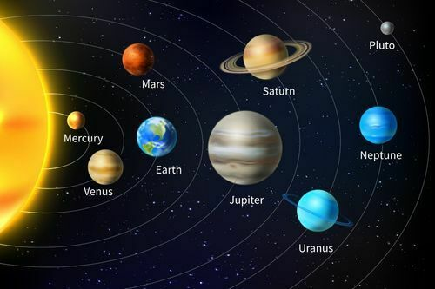 | 3 Marks

